# Week 1: Introduction to Machine Learning

## Types of Machine Learning

### Supervised Learning

* Learning from data labelled with the “right answers”
* Regression
  + Predicting any number from an infinitely many possible outputs
* Classification
  + Predict the category from a small number of possible outputs
  + Presence of 2 or more inputs
    - Uses boundary line to divide outputs into different categories.
    - Output category is determined on which area the input variables falls in

### Unsupervised Learning

* Find structure in unlabelled data
* Clustering Algorithm
  + Clustering is used when the data cannot be grouped as it has no given output. Hence, the algorithm tries to automatically group them into clusters

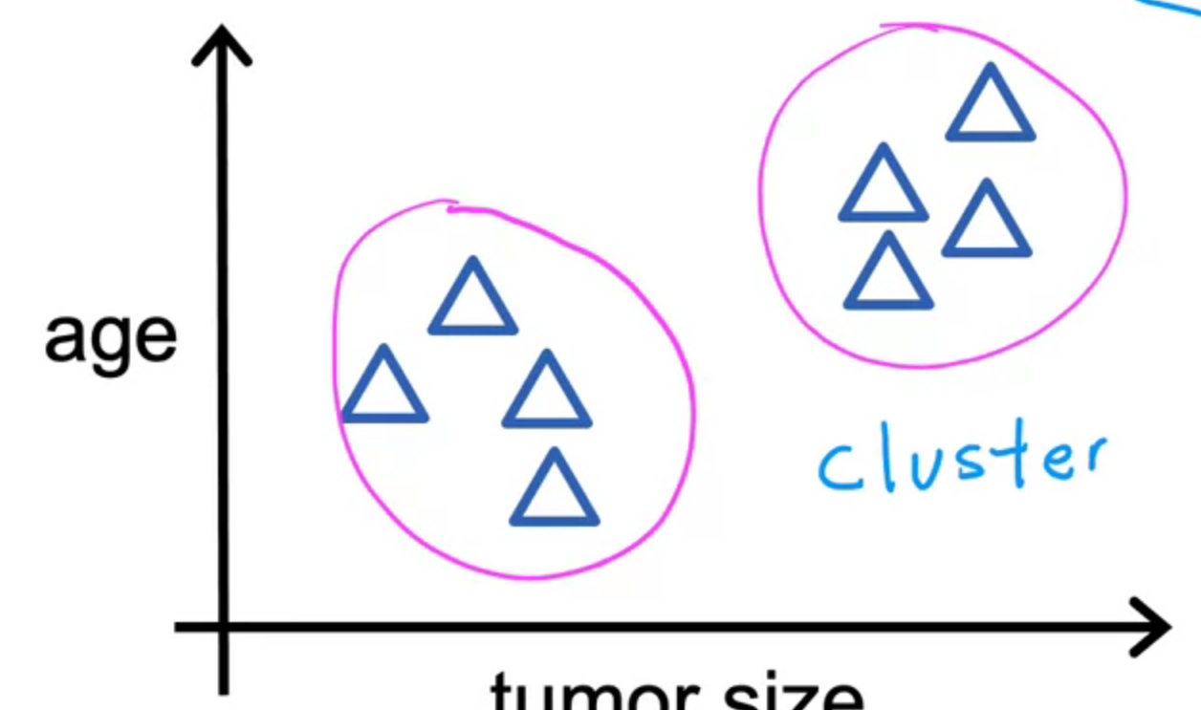

* + Different from classification
    - Classification is used when data can be grouped on their given output
    - Eg.

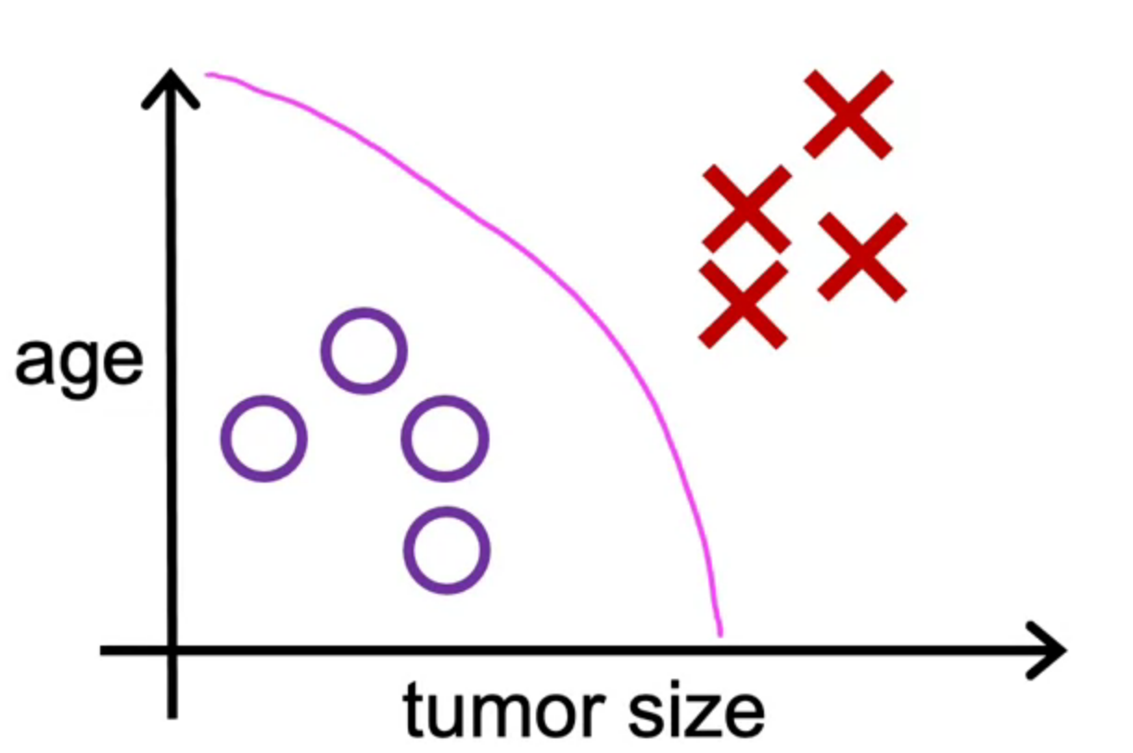

X: Cancerous tumor

O: Benign tumor

* Anomaly Detection
  + Finding unusual data points
* Dimensionality Reduction
  + Compressing data using fewer numbers

## Terminology

* Training set: Data used to train the model
* x = input variable feature
* y = output/ target variable
* $\hat{y}$ = predicted y
* m = number of training example
* (x, y) = simple training example
* ($x_{i} ,y_{i}$) = $i^{th}$ training example

## Linear Regression

* Linear
  + Cost Function
    - aka Squared Error Cost Function
      * + Can remove the 2 from $\frac{1}{2m}$

However, as $J\left(w,b\right)$ will be differentiated, the 2 will be removed after differentiation. Hence, will be better to keep the 2 to make the final output neater

* + - * + is squared to ensure that there is a minimum value
    - Visualization
      * 3D Surface Map

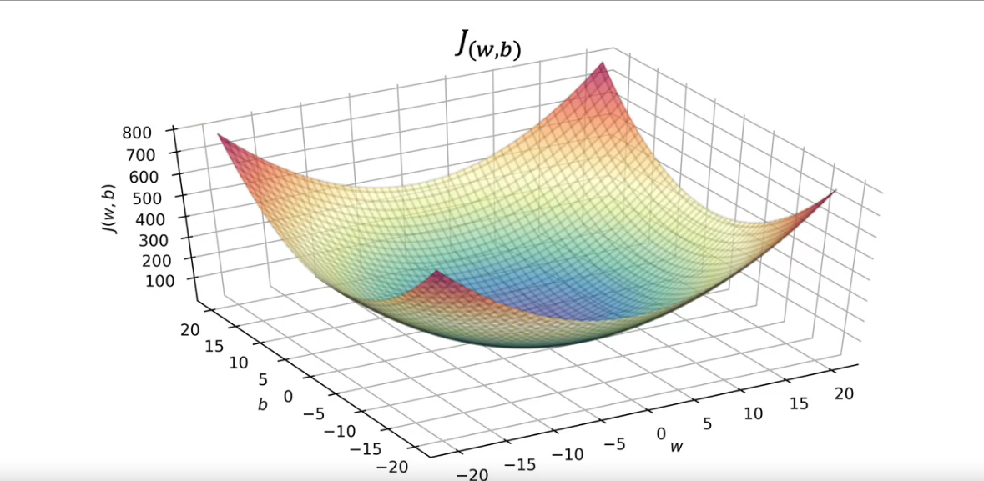

* + - * + Length & Breadth = w & b
        + Height = Value of J
      * Contour Map

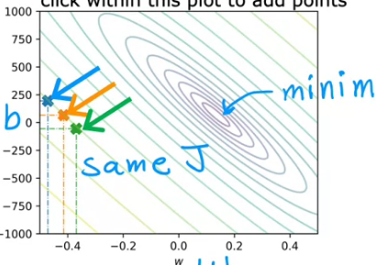

* + - * + Length & Breadth = w & b
        + Height = Value of J
        + The smaller the gaps between the lines, the lower the height of J
        + Values of J that fall on the same line (blue, orange, green) share the same value, even if w & b differs

## Gradient Descend

* Conducted to find the minimum J
  + Firstly, estimate a value for w & b
  + Secondly, find the next estimate of w & b which gives a lower J
  + Repeat step 2 until the next estimate of w & b no longer gives a lower J

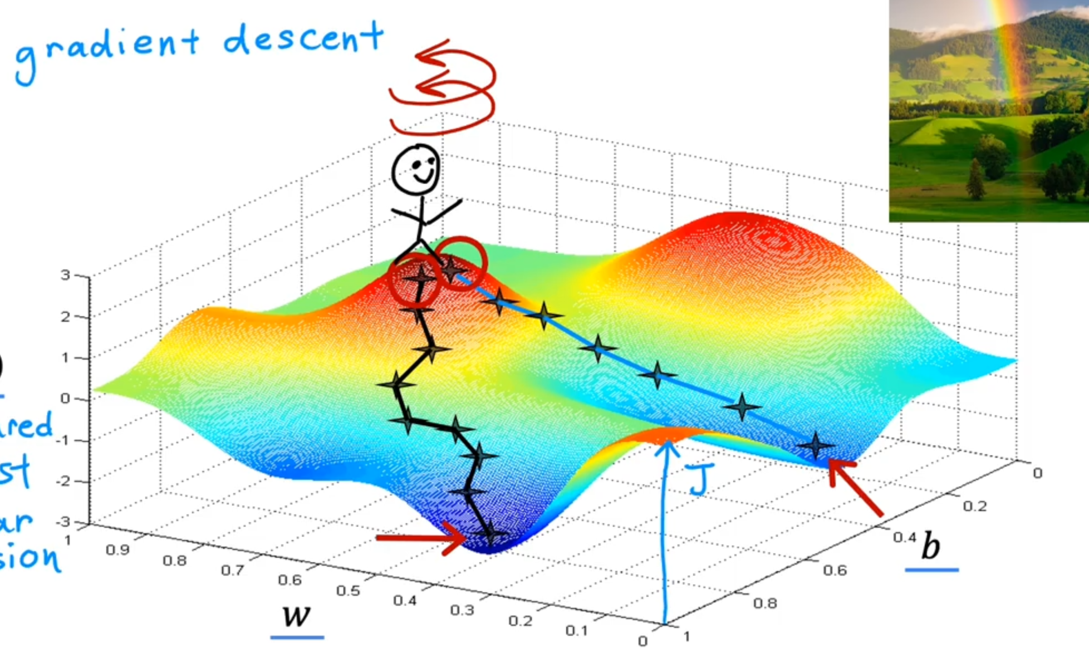

* It is possible to have more than one minimum J if the cost function is NOT:
  + Squared Error Cost
  + Linear Regression
* Gradient Descent Algorithm
  + Program that is repeated until convergence

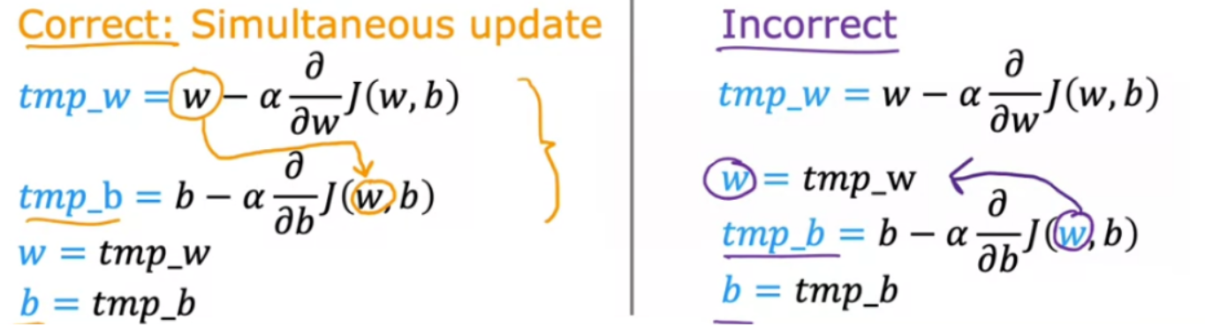

* + - Both w and b should be updated simultaneously
      * This means that we will change both w and b at the same time
      * If we update w before updating b, what happens is that $tmp_{b}$ will be based on the updated w and hence, the updated b will have a different value as compared to the b from simultaneous update
  + Convergence refers to where $\frac{d}{dw}J\left(w,b\right)$ = 0
    - This is because no change in w & b will bring about minimum J
    - $\frac{d}{dw}J\left(w,b\right)$ is the gradient of the cost function on a cost to w OR b graph
      * $\frac{d}{dw}J\left(w,b\right)$ = 0 is where cost function, and cost, is at the minimum
    - On a cost-iterations graph, J should decrease as iterations increase. If J increase, this means that
      * $α$ is too large and overshot $J_{min}$;or
      * $w_{1}= w_{1}+ αd_{1}$ instead of $w_{1}= w_{1}- αd_{1}$
* Learning Rate $α$
  + A small $α$
    - Increase the number of steps taken to reach $J_{min}$ thereby increasing the time needed to complete gradient descent

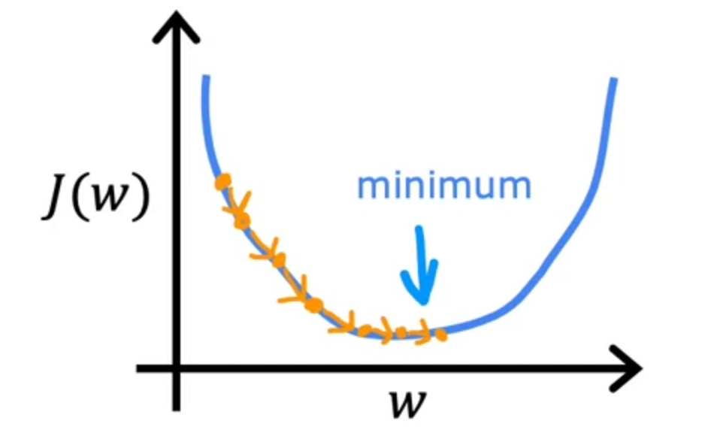

* + A large $α$
    - May never complete gradient descent as it might overshoot the $J_{min}$, thus failing to converge and diverge away from

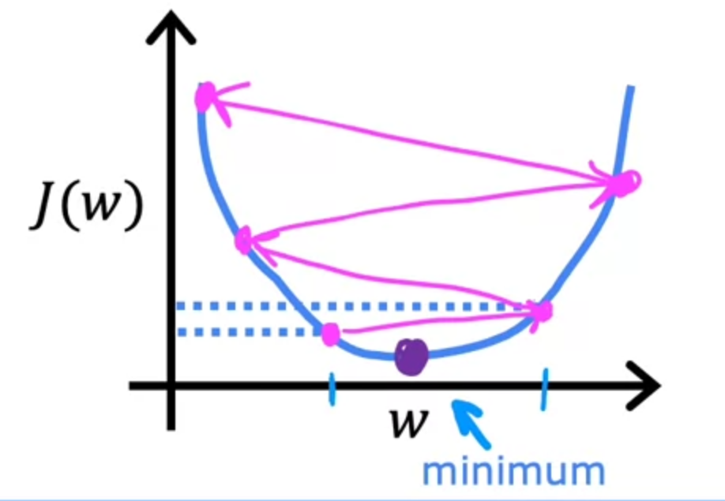

* + What if J is already at a local minimum?
    - No change and will remain as local minimum

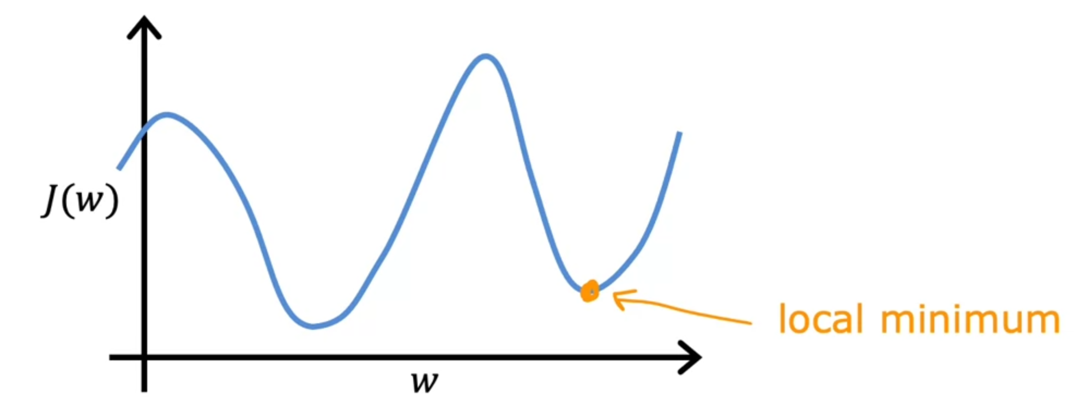

* Linear Regression Differential for Gradient Descent

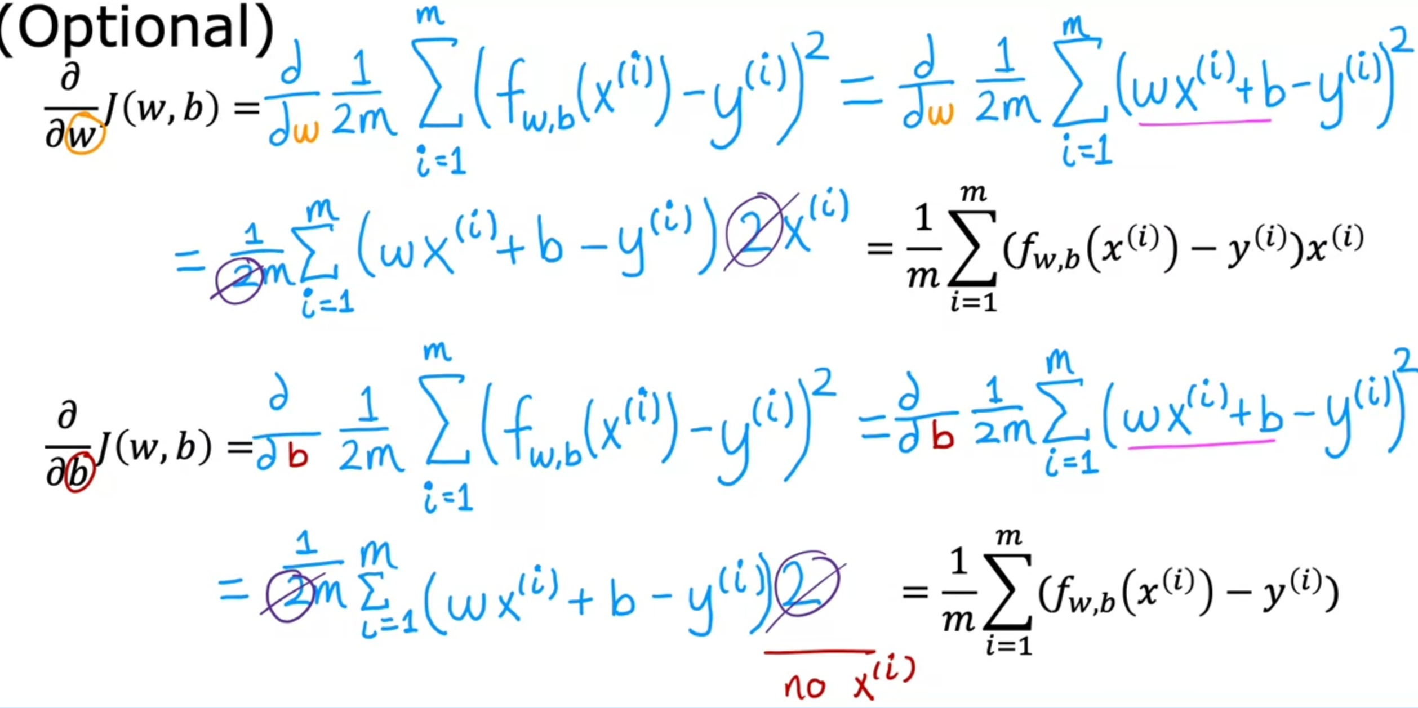

* Batch Gradient Descent
  + “Batch” – Each step of gradient descent uses all of the training data

# Week 2: Multiple Linear Regression

## Multiple Features

* $x_{j}^{i}$ = $i^{th}$ example of feature $j^{th}$
* $\overset{⃑}{x}$ = vector of X **OR** list of numbers for x
* Multiple Linear Regression Equation

$f_{\overset{⃑}{w},b}\left(\overset{⃑}{X}\right)= \overset{⃑}{w}⋅\overset{⃑}{x}+b=f_{w,b}\left(X\right)=w_{1}x_{1}+ w_{2}x_{2}+…+{ w}_{n}x_{n }+b$

## Vectorisation

* Vectorisation makes the code:
  + Easier to read and write
  + Runs faster
* How to use vectorization in Python

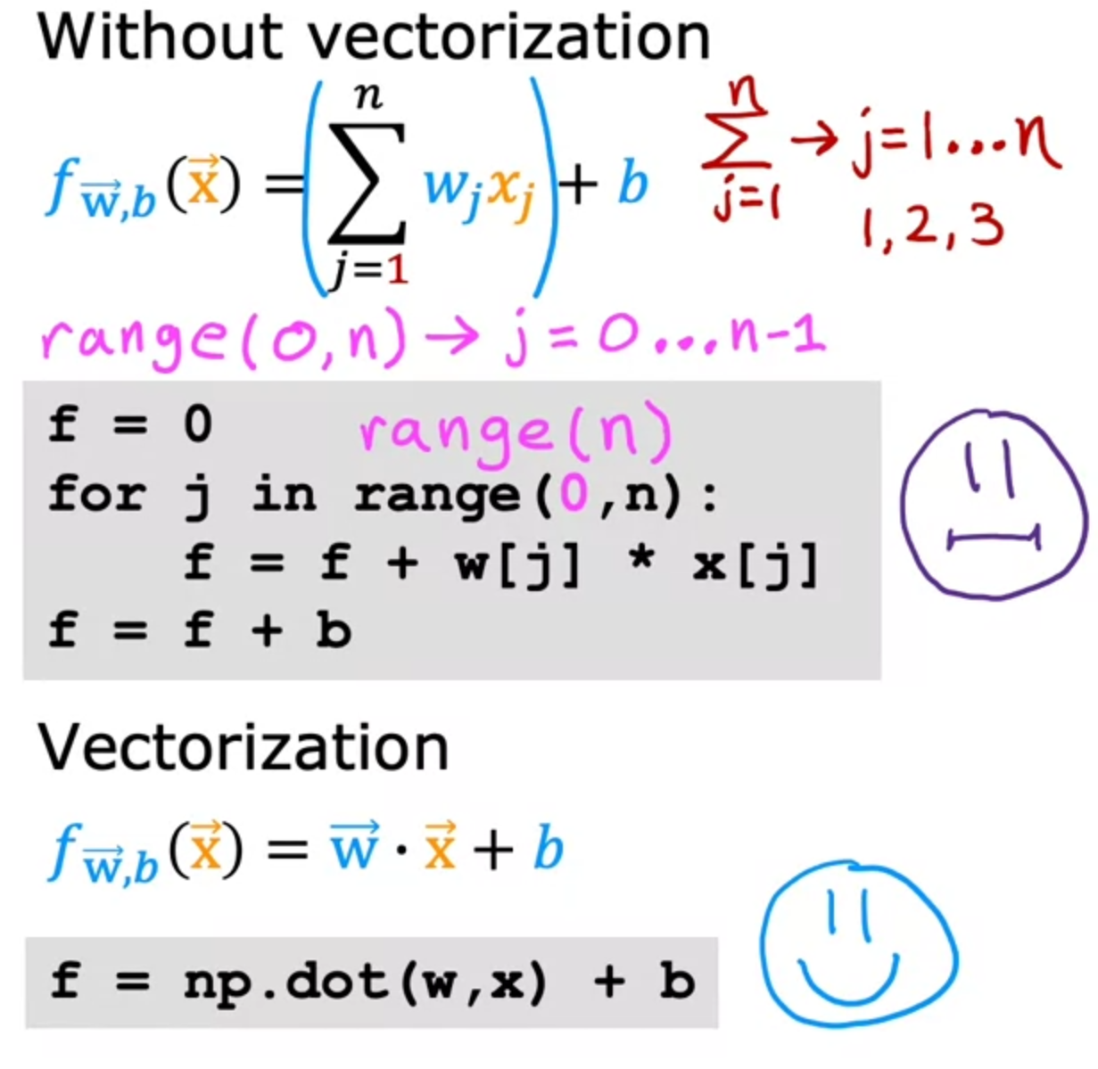

* Vectorisation is faster than for loop as numpy calculate algorithm using parallel hardware
  + Parallelism means that computer will use their hardware to calculate the independent equations simultaneously before aggregating them
  + In contrast, for-loops does the algorithm in sequential steps
  + Vectorisation can also be used if the model runs on a GPU

## Gradient Descent

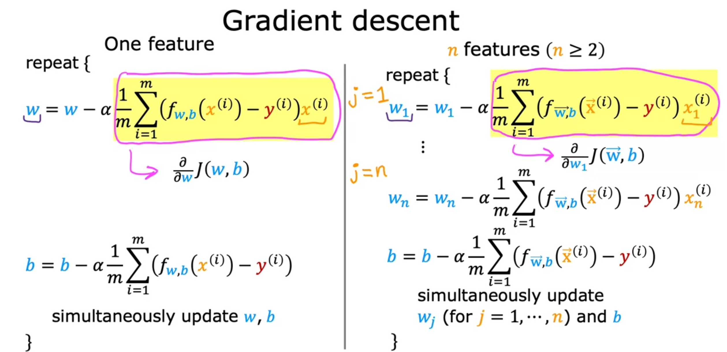

### Feature Scaling

* Features not scaled correctly will have uneven contours, thereby increasing the number of steps taken by gradient descent to reach global minimum

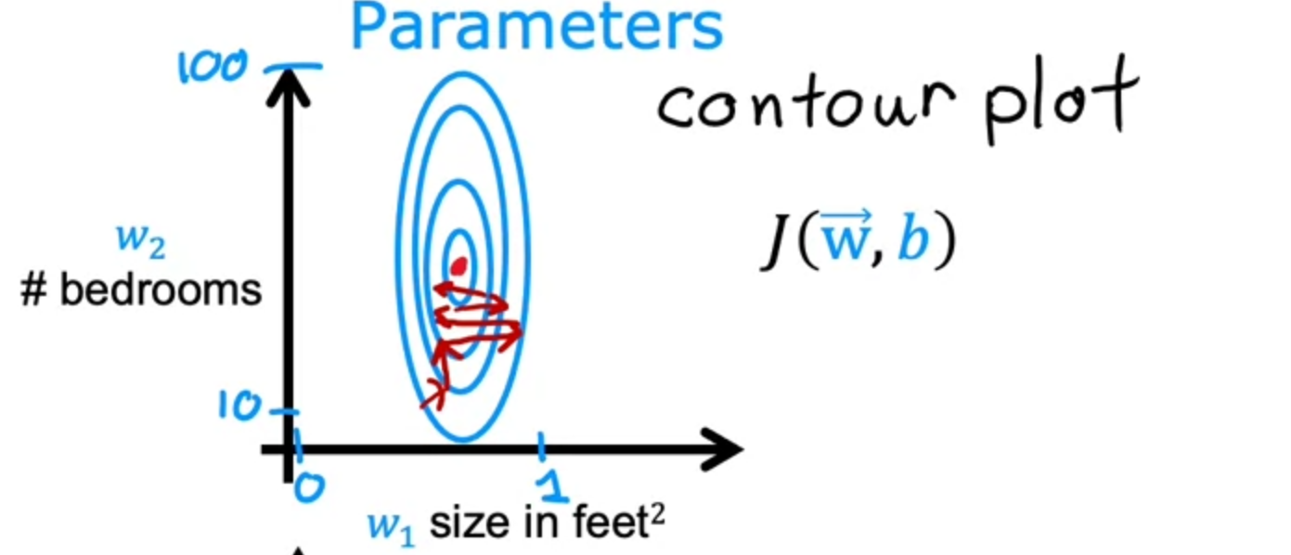

* By scaling them, contours will be more even, and gradient descent can find a more direct path to global minimum

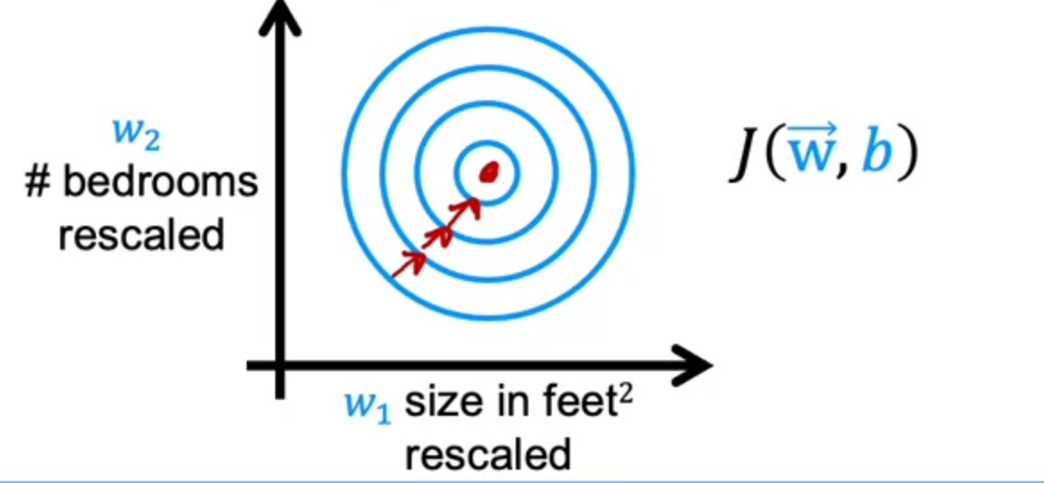

* + Two methods:
    - $x_{scaled}= \frac{x}{x_{max}}$**Feature Scaling**
    - $x_{scaled}= \frac{x- μ }{x_{max}- x_{min}}$**Mean Normalisation**
    - $x_{scaled}= \frac{x- μ }{σ}$**Z-Score Normalisation**

### Feature Engineering

* Using intuition to design new features, by transforming or combining original features
* Polynomial Regression
  + By using the powers of individual features, feature scaling becomes important as the values of each feature would differ from the others exponentially

# Week 3: Classification

## Motivations

* Threshold
  + Using probability and regression to determine which category an input belongs to
    - It does not work often as the presence of outliers will shift the classification decision boundaries to inaccurate levels
      * Eg. Binary Classification
        + An ‘1’ input may be classified as ‘0’ due to the presence of anomalous data

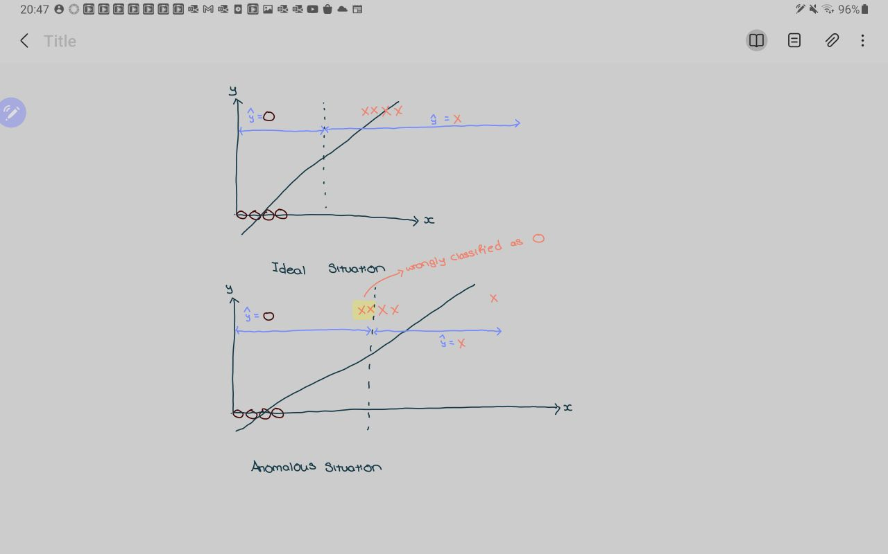

## Logistic Regression

* Utilised the Sigmoid Function (aka logistic function)

$g\left(z\right)= \frac{1}{1+e^{-z}} , 0<g\left(z\right)<1$

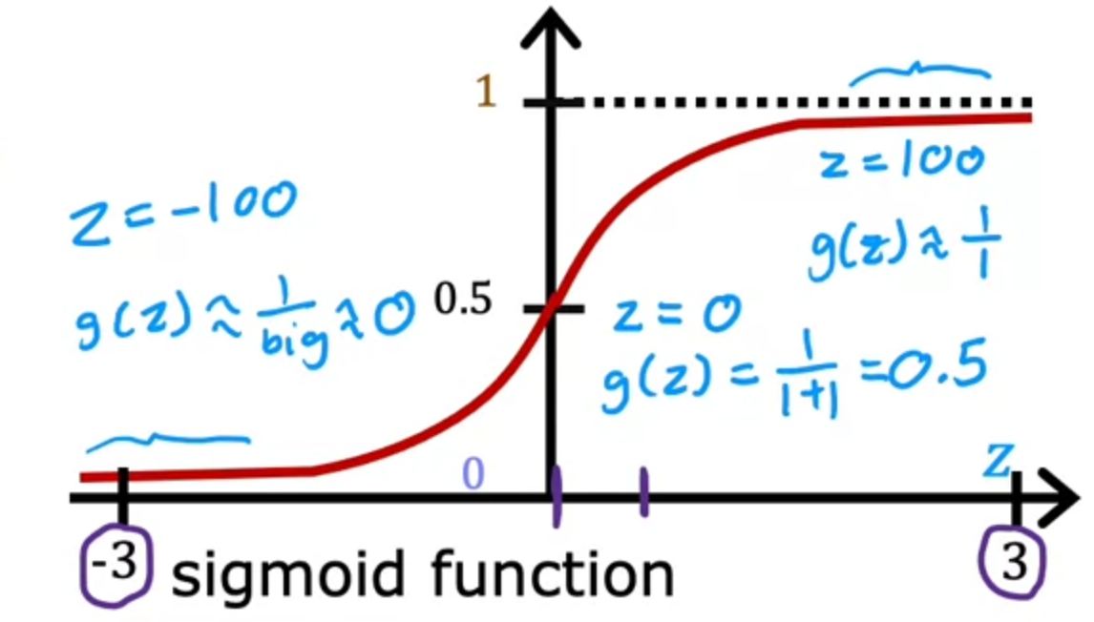

* Equation
  + $f_{\vec{w}, b}\left(\vec{x}\right)= \vec{w} ∙ \vec{x}+b$ = z
  + Hence, $g\left(z\right)=g\left(\vec{w} ∙ \vec{x}+b\right)= \frac{1}{1+e^{-(\vec{w} ∙ \vec{x}+b)}}$
* Output of logistic regression is sometimes given as $P\left(y=1 \right| \vec{x};\vec{w},b)$
  + aka Probability that y = 1 given input $\vec{x}$, parameters $\vec{w}$& b

## Decision Boundary

* Linear Decision Boundaries
  + A straight line of conditional probability that separates the different categories
  + Happens when features are not engineered or polynomials
  + Linear Decision Boundary formed by $g\left(z\right)= \vec{w} ∙ \vec{x}+b$ is $\vec{w} ∙ \vec{x}= b$ where $g\left(z\right)=0$

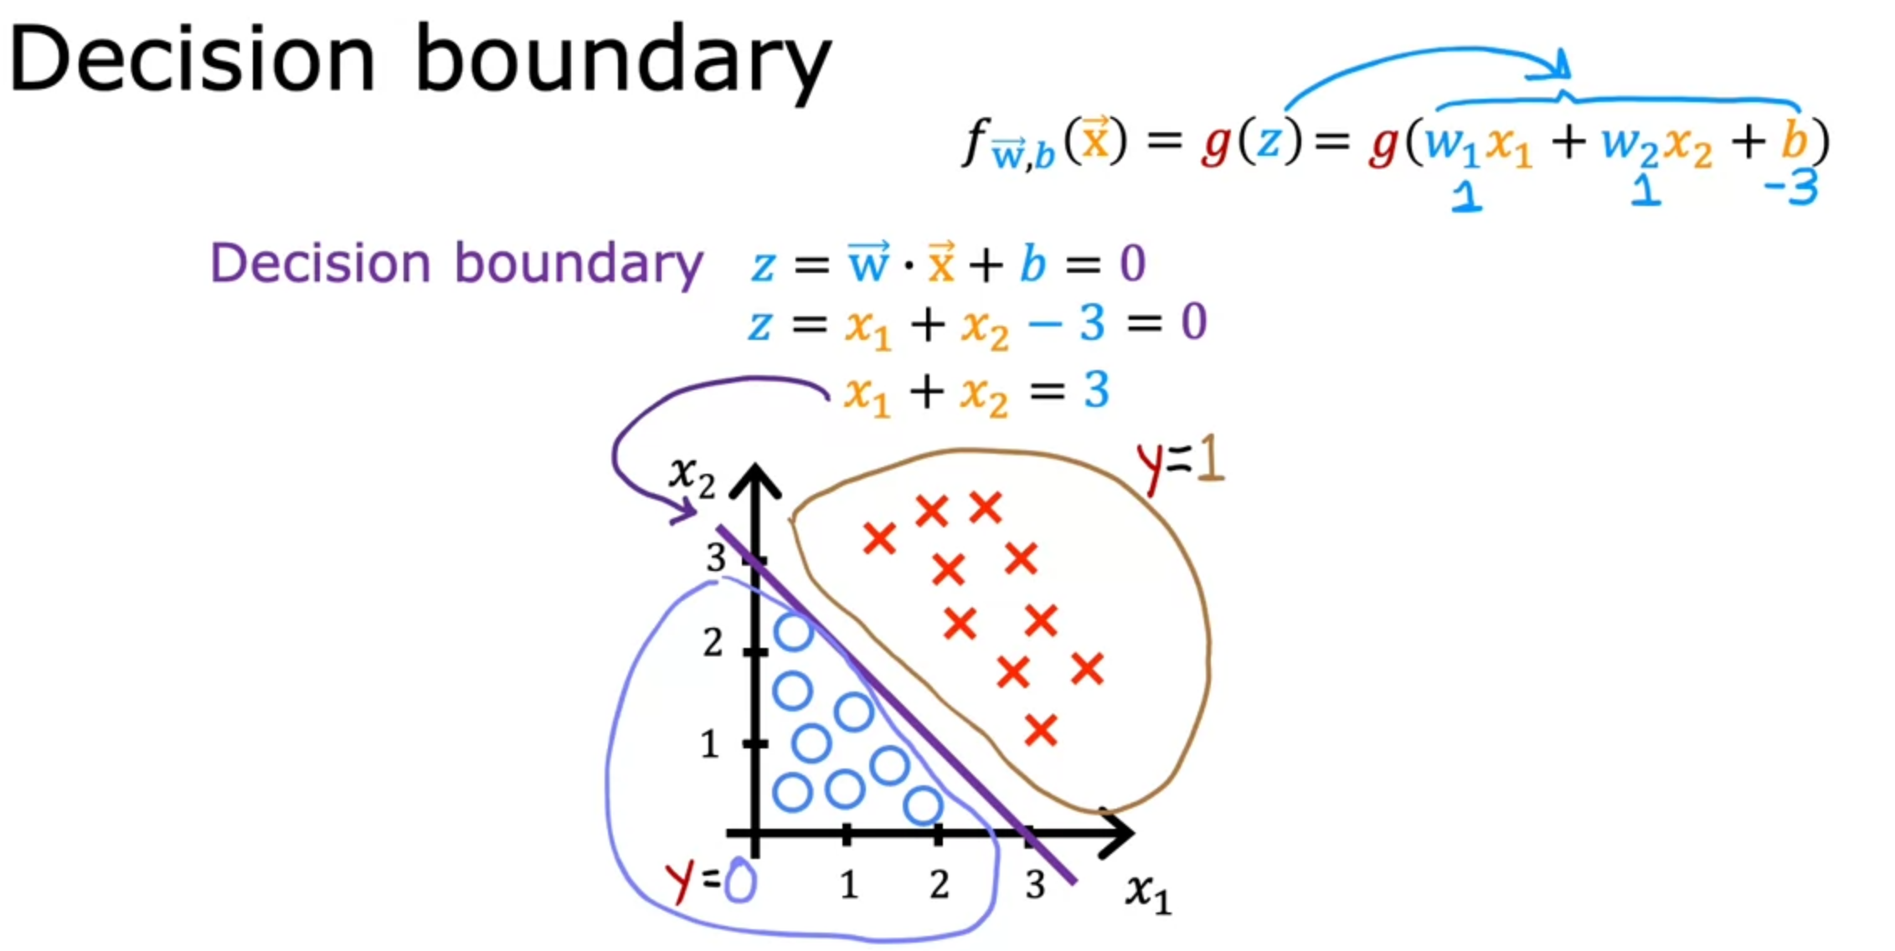

* Non-Linear Decision Boundaries
  + Occurs when there is no clear linear boundary and thus we have to map features to form non-linear boundaries. This causes features to become polynomials

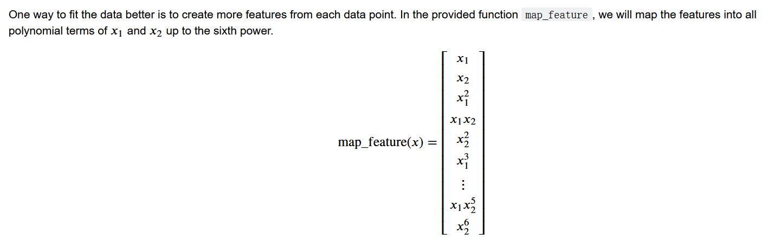

In this case, by increasing vectors to 27-dimension, it forms a more accurate decision boundary

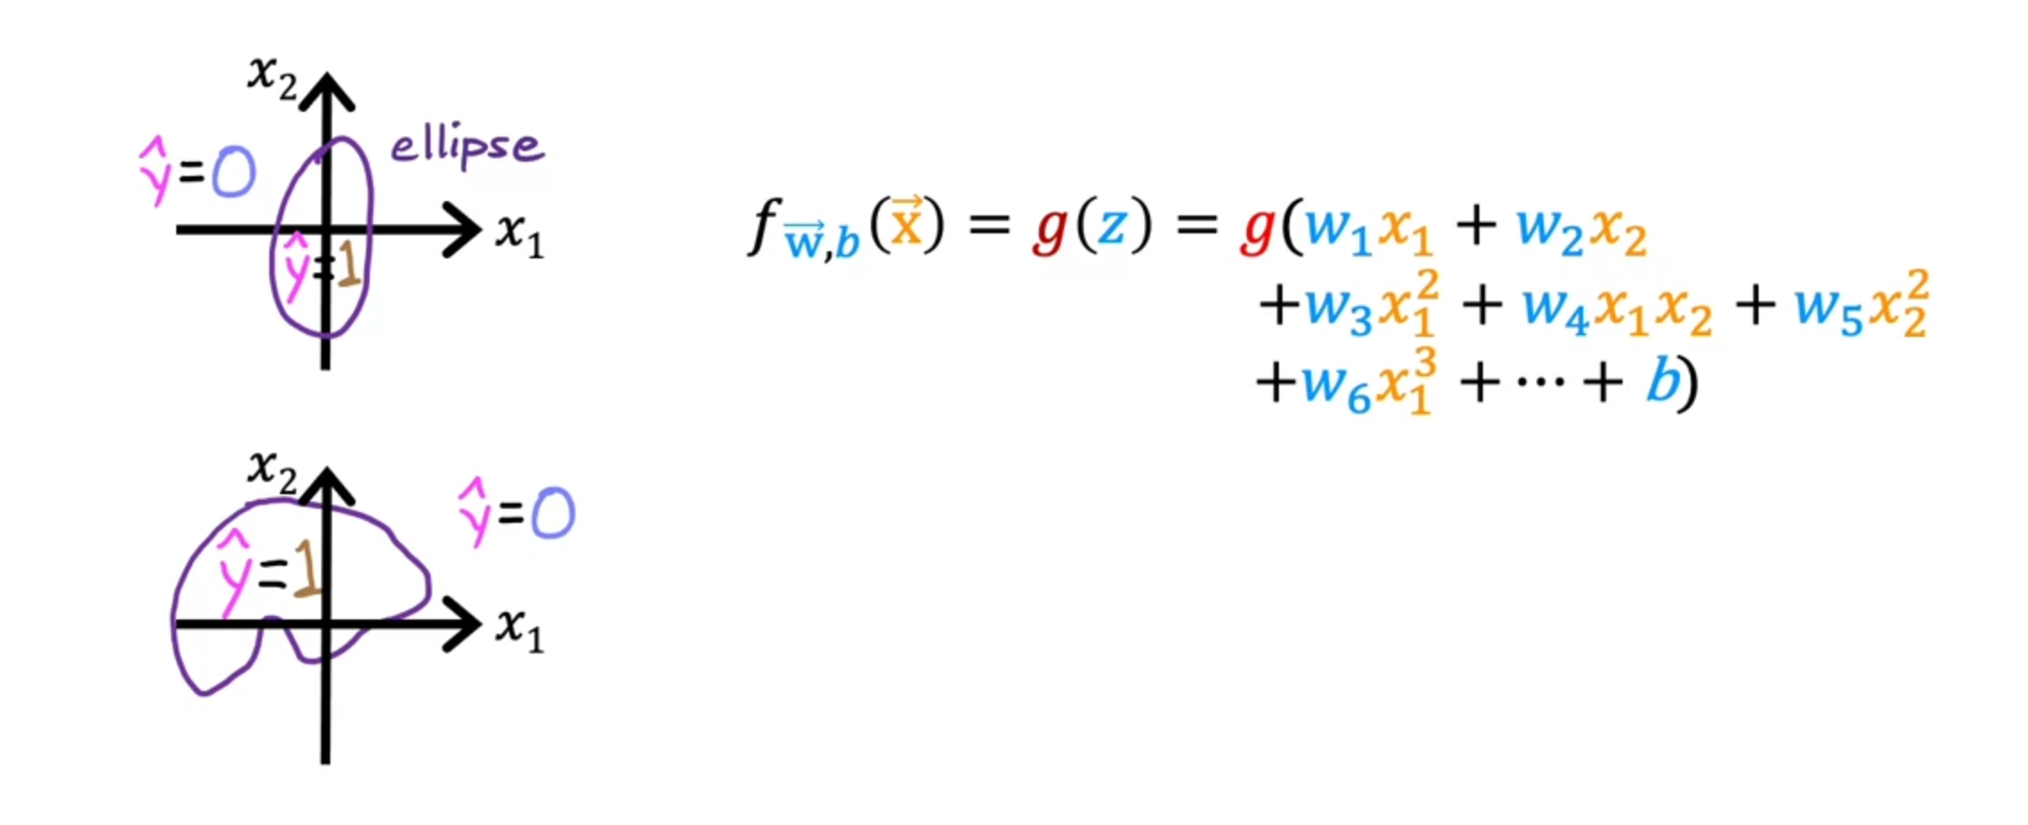

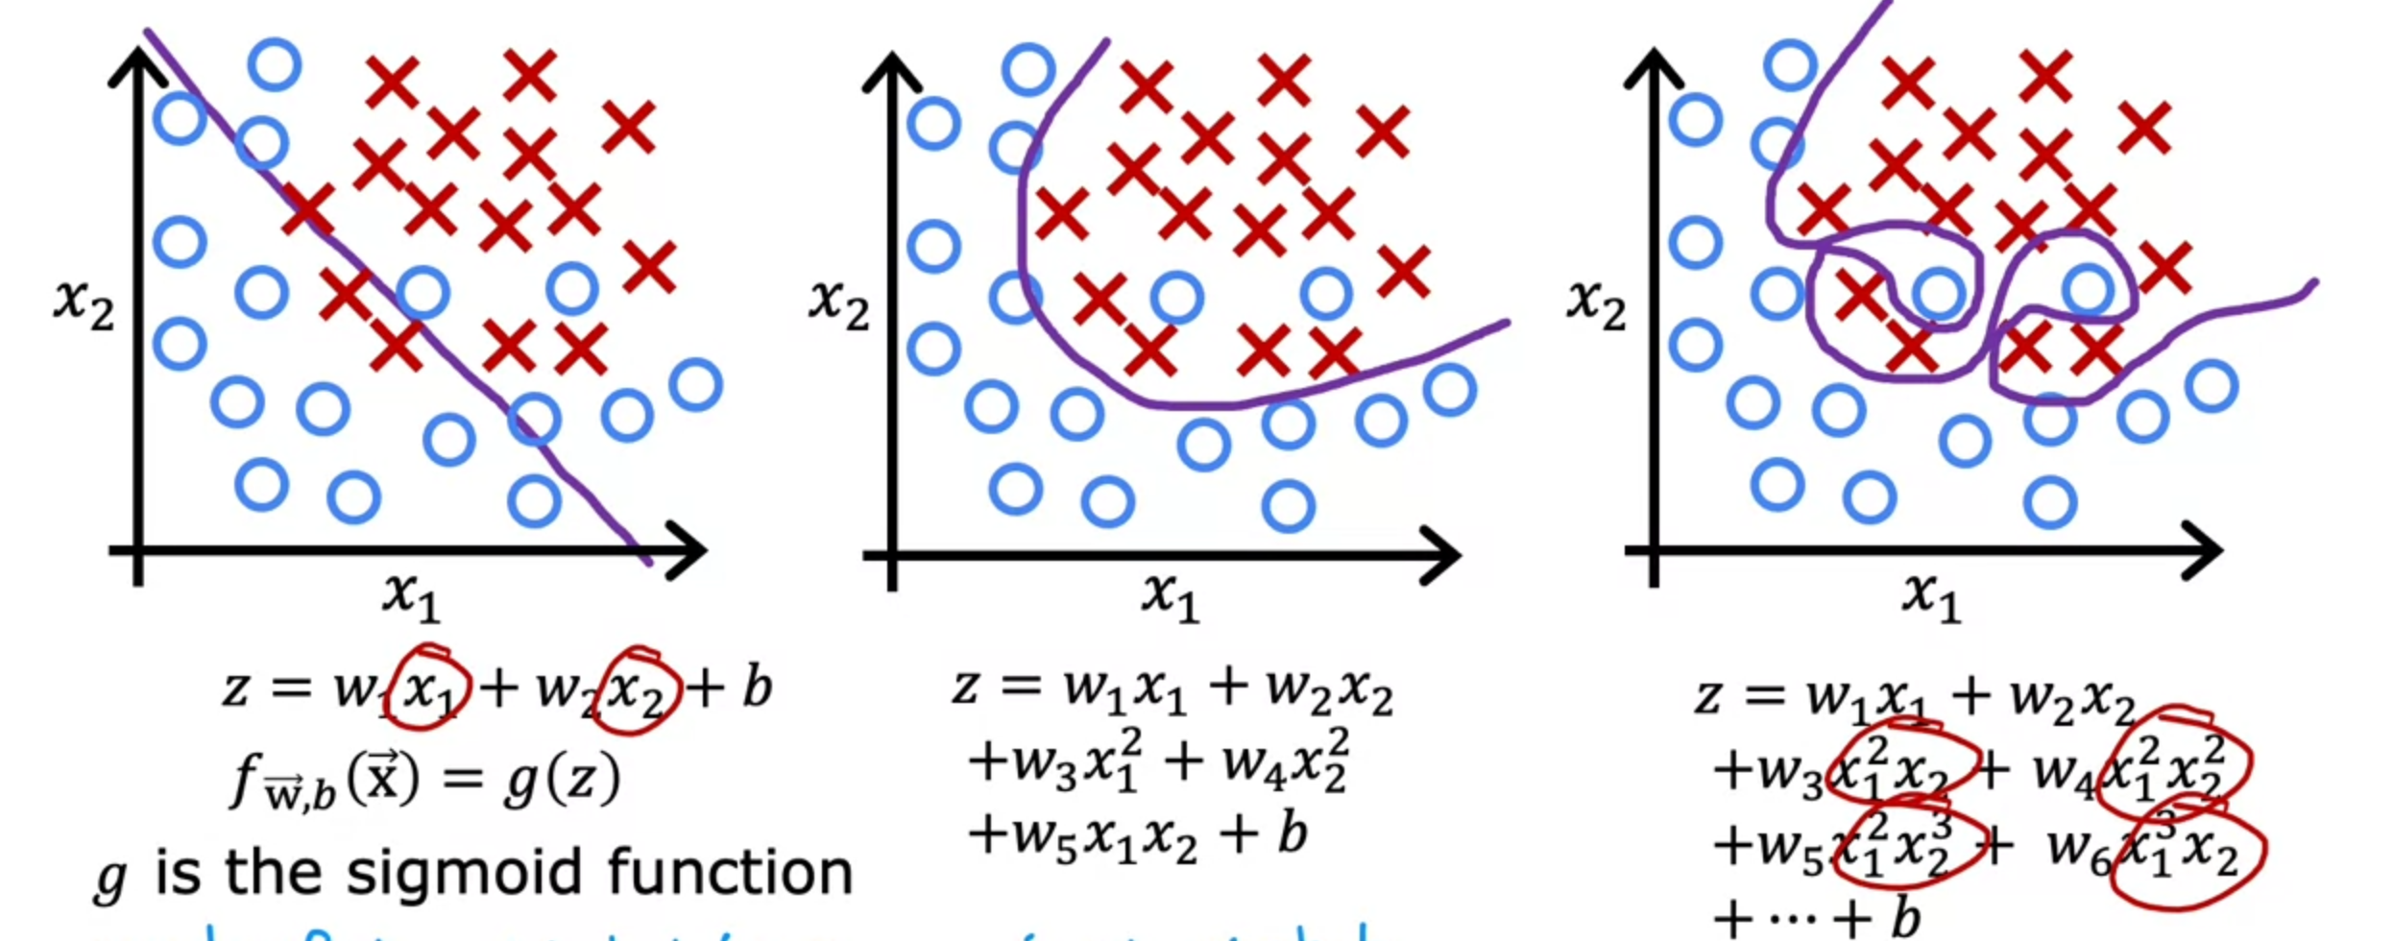

## Cost Function

* Logistic Regression cannot use squared error cost function
  + Squared error cost function for linear regression is convex

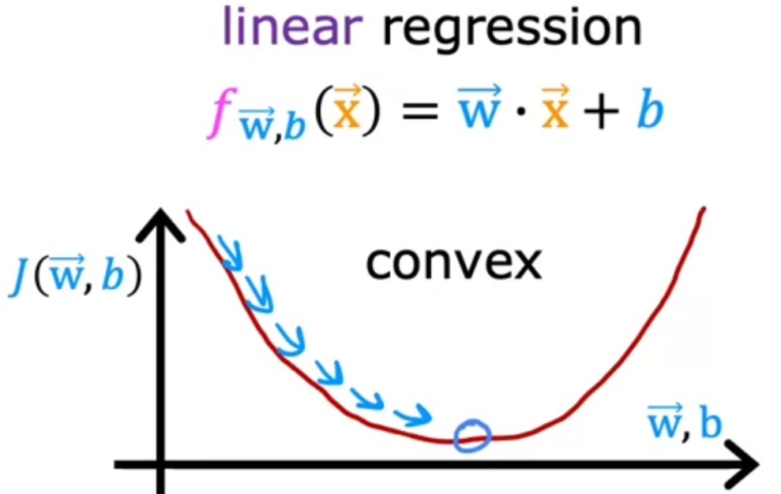

* + However, squared error cost function for logistic regression is non-convex for logistic regression
    - Hence, Gradient Descent will be sucked into the many local minima present in the cost function

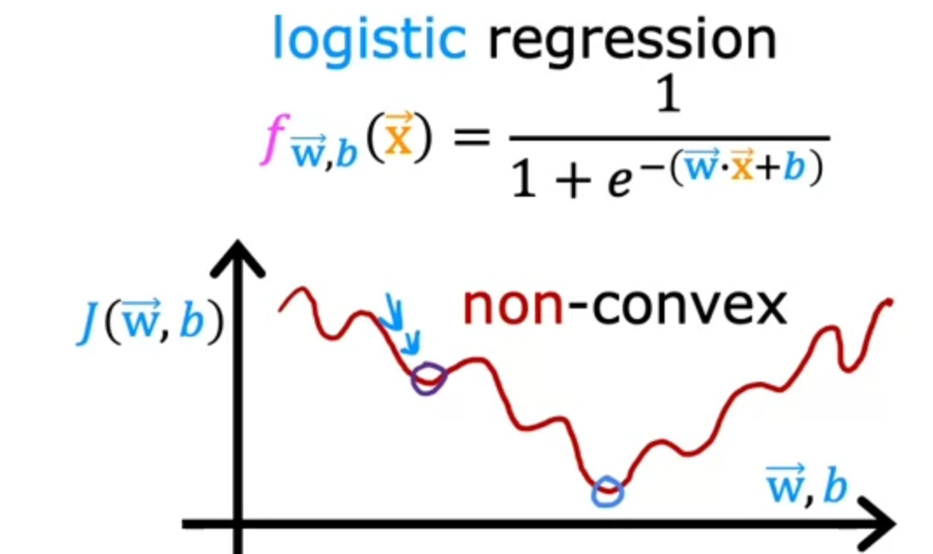

**Local Minima**

* Logistic loss function

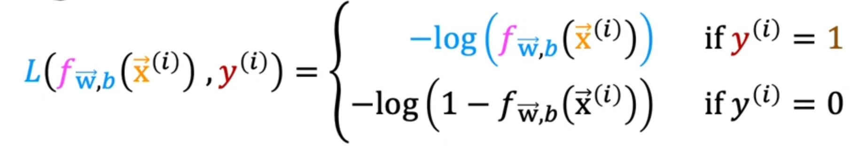

**Expanded**



**Simplified**

* + When $y_{i}=1$, loss increases more than proportionally as $\hat{y_{i}}$ decreases

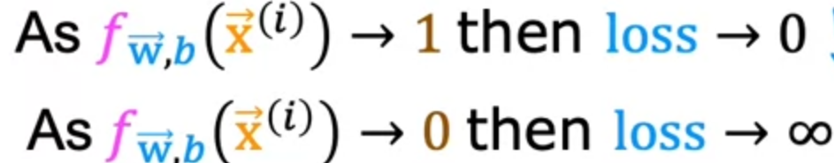

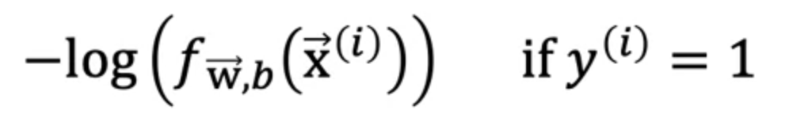

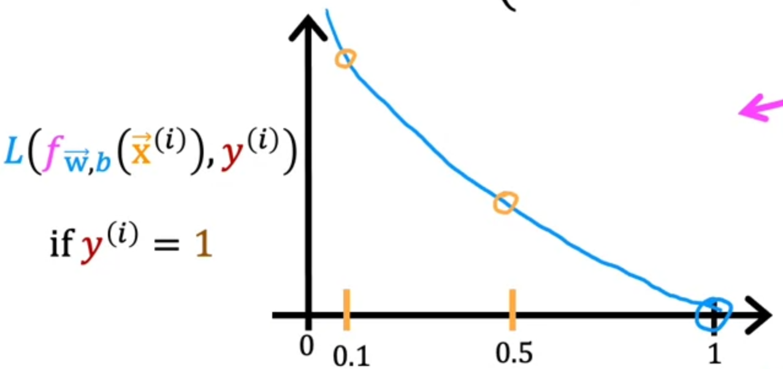

* + When $y_{i}=0$, loss increases more than proportionally as $\hat{y_{i}}$ increases
    - 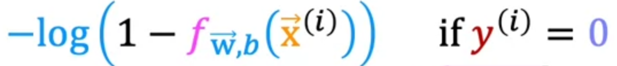

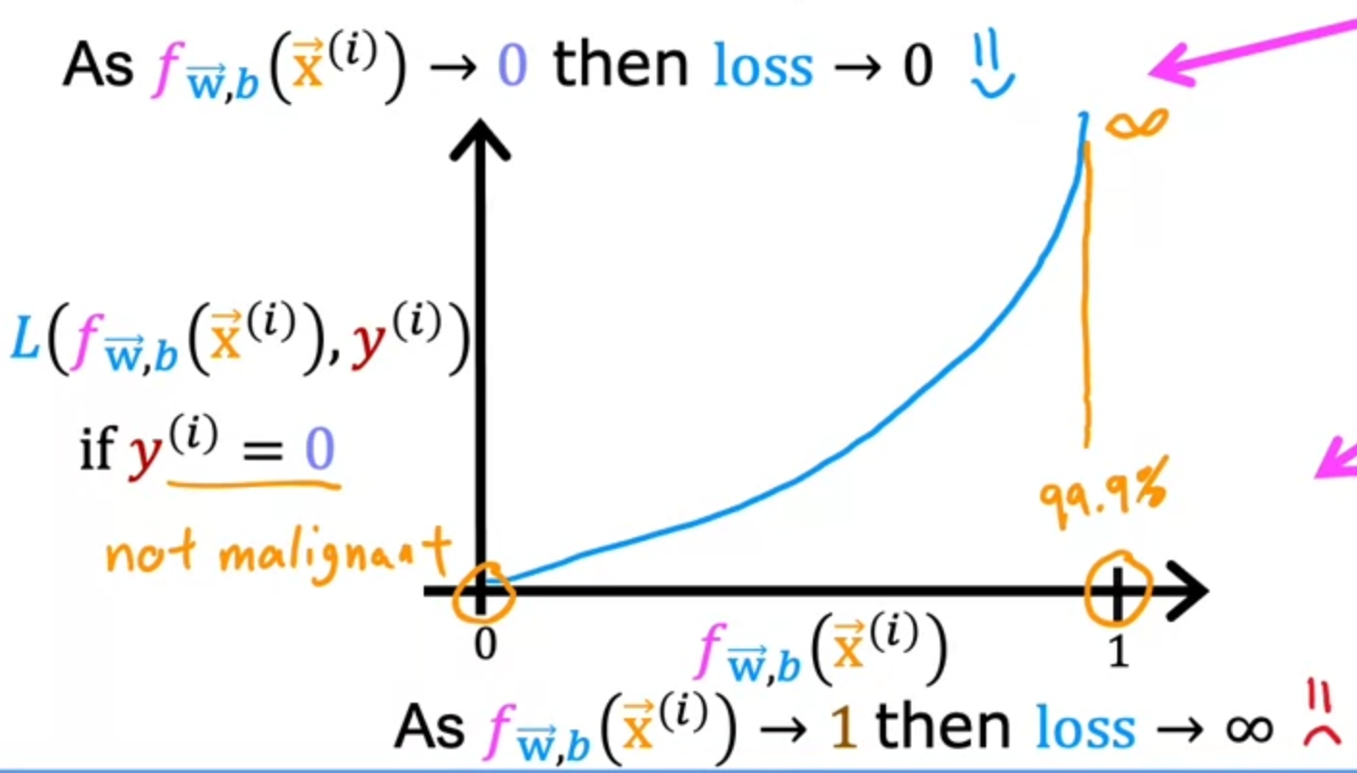

* + Generally, the logistic loss function creates a convex curve, allowing the model to reach a global minimum to find the corresponding values that bring about the lowest cost
* Cost Function
  + Summation of Loss Function

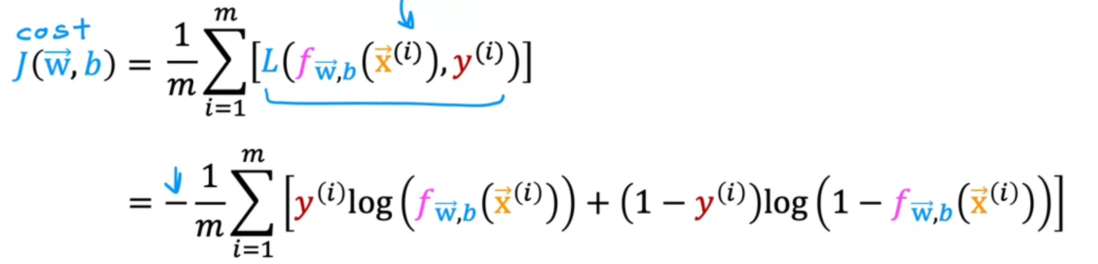

* + Derived through a statistical principle known as **Maximum Likelihood Estimation**

## Gradient Descent

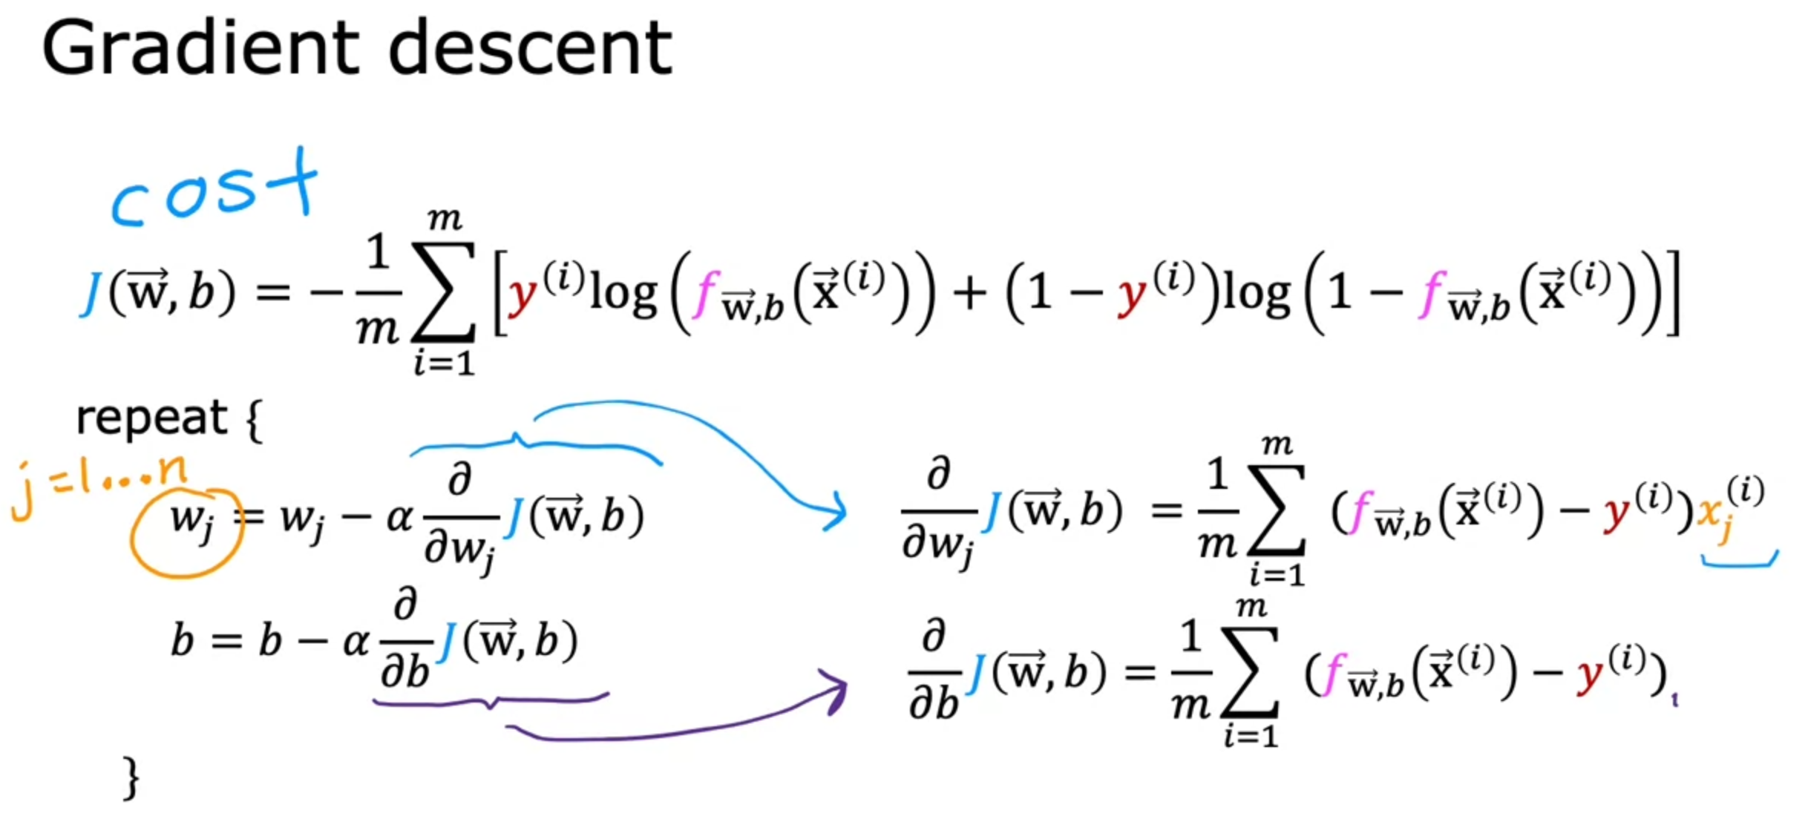

* Even though the equations look the same as linear regression, $f_{\vec{w}, b}\left(\vec{x}\right)$ here refers to the sigmoid function and not $\vec{w}∙\vec{x}+b$
* Similar to linear regression, logistic regression can apply the following concepts:
  + Vectorisation
  + Feature Scaling
  + Monitoring for convergence

## Fitting of Models

* Types of fits
  + Overfitting
    - Fits the training set extremely well - fits every single training data point
    - Includes any anomalies
    - Deemed to have high variance where a slight difference in dataset would have completely different or highly variable predictions
  + Generalisation
    - Fit the training set well
  + Underfitting
    - Does not fit the training set well
    - Deemed to have high bias caused by misconceptions of dataset
* How to prevent overfitting
  + Collect more data to reduce impacts of outliers
  + Feature selection
    - Selecting the relevant features when you have too many features but not enough training data
    - Disadvantage
      * Losing some useful features which will reduce accuracy of prediction
  + Regularisation
    - Shrink the factors of features, aka w, such that all features can be kept but prevent them from having an overly large effect

## Regularisation

* Done to reduce overfitting of data
  + Creates a simpler model
  + Less likely to overfit as it creates a smoother curve
* $J\left(\vec{w}.b\right)=\frac{1}{2m} \sum_{i=1}^{m}{{(f_{\vec{w},b}\left(x_{i}\right)- y_{i})}^{2}+ \frac{λ}{2m}\sum_{j=1}^{n}{w_{j}^{2}}}$, **regularisation term**
  + $λ$ = Regularisation Parameter > 0
    - Divided by 2m to scale it to the Mean Squared Error
      * Easier to choose a value for $λ$ and keep it constant
  + Must balance between minimizing mean squared error and regularization term
    - If $λ$ = 0, curve will overfit
    - If $λ$ = $∞$, regularization term will be extremely large. Hence, we must reduce $\vec{w}$ to 0 to minimize Cost, J, and as a result curve will underfit

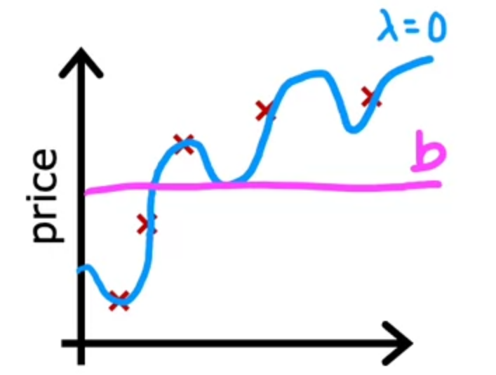

* Linear Regression

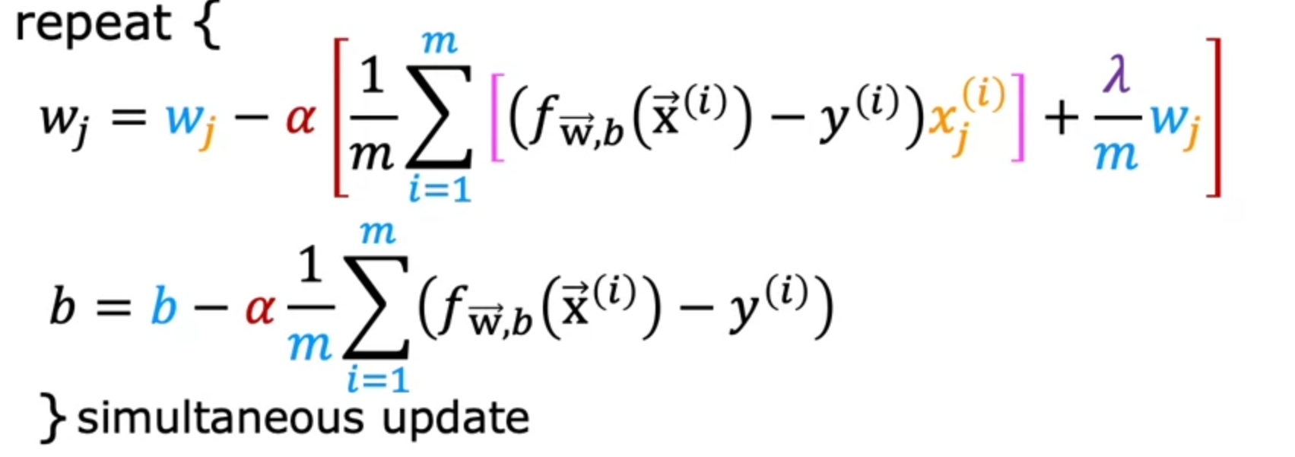

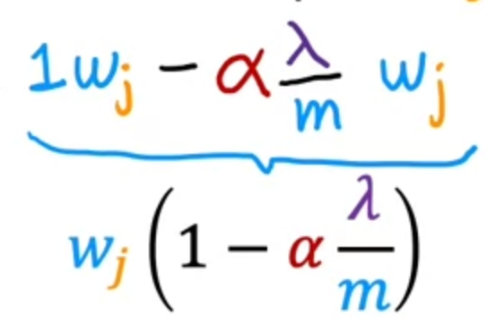

**every iteration of w will be decreased (regularised) by this factor**

* Logistic Regression
  + Same as linear regression except $f_{\vec{w},b}\left(x_{i}\right)$ is the sigmoid function

# Additional Notes

* Some ML engineers uses GPU to accelerate their ML models training
  + NOTE that GPU refers to the ones by Nvidia. Intel lacks the capability
* Alternative to Gradient Descent
  + Normal Equation

* + - Only used for linear regression
    - Solved for w & b without iterations
    - Useful for dataset with small features
      * Slow when number of features is large
    - Additionally, it might be used in ML libraries that implement linear regression. If so, might not be able to be used if number of features is large
* Algorithm Complexity
  + Gradient Descent = O(K $n^{2}$) **quadratic graph**
  + Normal Equation = O($n^{3}$) **matrix inversion**
  + Regularisation of b has little to minimal effect. Hence, data scientists seldom regularise b